1. Compare the C/C++ Arrays to Python Lists.

C++ arrays are almost identical to c arrays with only a few differences. Once such being Python lists are resizable, C++ arrays can’t be resized. There are also some differences to how the arrays get stored, but they can still serve as basically the same thing with only slight tweaks.

2. Write a C/C++ program which allows to input an array of 15 elements. Show the source code and show the test (s)

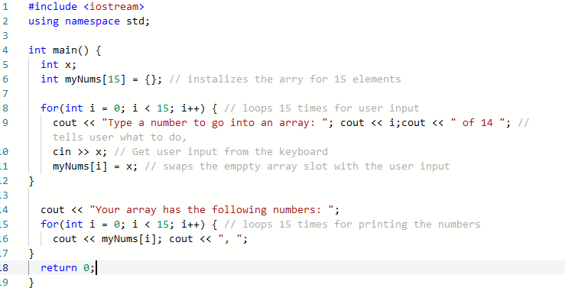

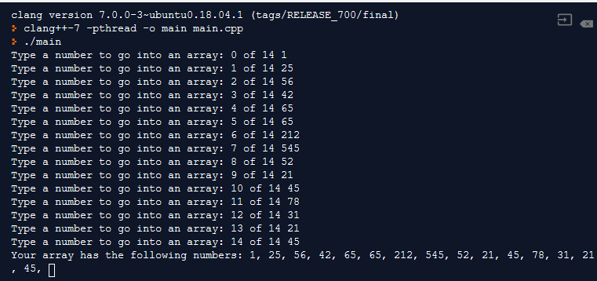

Some tests done

Regular numbers: works as expected

Negative numbers: works fine

Larger numbers: causes an overflow and messes up the code

Non- int inputs: causes a crash as well

Inputting Decimals: causes a crash